

**Bird training system**

**Final Release Document**

– Ho Chi Minh city, June 2023 –

**Table of Contents**

I. Deliverable Package 3

II. Installation Guides 3

III. User Manual 3

1. Overview 3

2. Private Consultation 4

2.1 Guest 4

2.2 User 4

2.3 Staff 5

2.4 Trainer 7

2.5 Staff 8

3. Blog 9

3.1 Staff 9

4. Workshop 10

4.1. User 10

4.2. User_Workshop 10

4.3. Staff 11

4.4. Staff 12

4.5. Staff 13

4.6. User_Edit Profile 14

4.7. Staff_Update workshop 16

5. Bird course 17

5.1. User 17

5.2. User 17

5.3. Staff 17

5.4. Staff 17

5.5. Trainer 17

6. Online course 17

6.1. User 17

6.2. User 17

# I. Deliverable Package

| **No.** | **File** | **Notes** |
| --- | --- | --- |
| 1 | SWP391.mdf | Database, including both table structures and table data |
| 2 | SRS Document_BS_Group 4.docx | Final SRS (Requirement) Document |
| 3 | SDS Document_BS_Group4.docx | Final SDS (Design) Document |
| 4 | Project Tracking_BS_Group4.xlsx | Final status for the application functions, which include:  - Function name, feature, roles, function description (changes compared to the original requirements are highlighted)  - In Charge, Planned iteration & Actual iteration  - Final status & note on the update you made  - The links to the SRS & SDS are tracked |
| 5 | Issues Report_BS_Group4.xlsx | Final issues tracking list of the whole project |

Other related deliverables:

* Tagged source codes: https://github.com/vuvohoang1823/SWP391-demo/tree/main
* Demonstration video: https://youtu.be/Tma2HEap82c

# II. Installation Guides

* Environmental install
* Netbeans
* SQL Server
* javax.mail.jar
* commons-fileupload-1.4.jar
* commons-io-2.6.jar
* sqljdbc4.jar
* Database
* Runcode
* Open Netbeans
* Connect Database with SQLServer
* Run the project

# III. User Manual

## 1. Overview

Today, more than ever, people are embracing the joy and wonder of owning birds as pets. Birds are intelligent, social creatures that bring beauty and charm to our lives. However, properly caring for and training birds can be a complex and challenging endeavour. That's where the Bird Training System comes in our system is a comprehensive online platform designed to facilitate the training and education of bird and bird owners. The system enables users to purchase various courses, including in-person workshops, online courses, consultations, and specialized training programs. Users have the option to send their birds to trainers for personalized training or engage in self-paced online learning. The system also provides a feature that allows users to track the progress of their birds' training through the website.

## 2. Private Consultation

### Guest

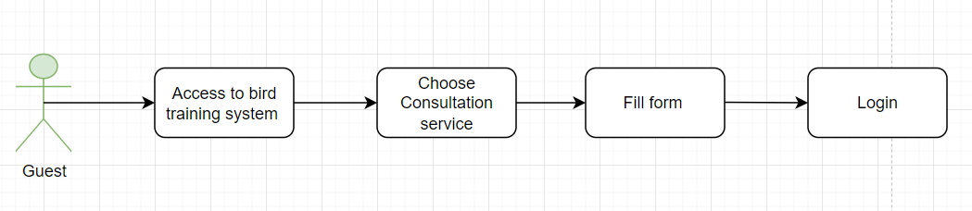

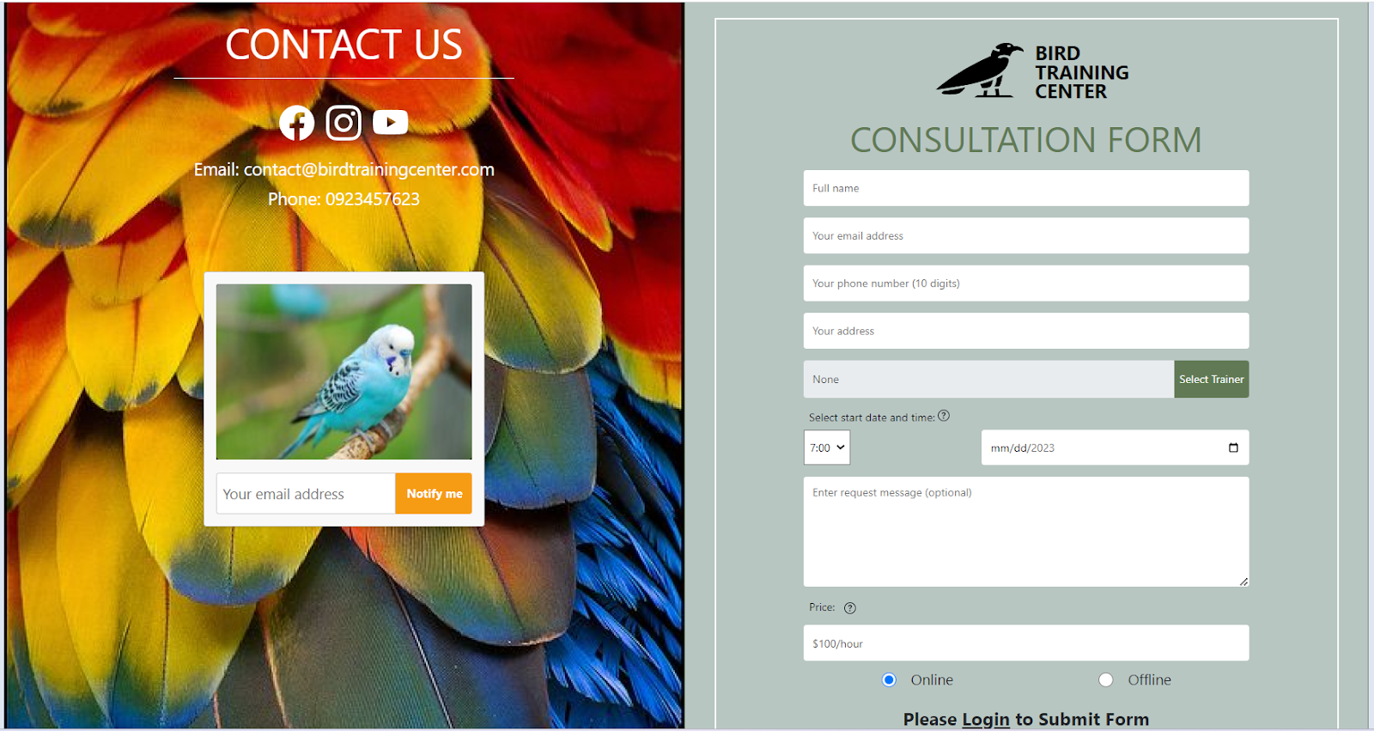

### User

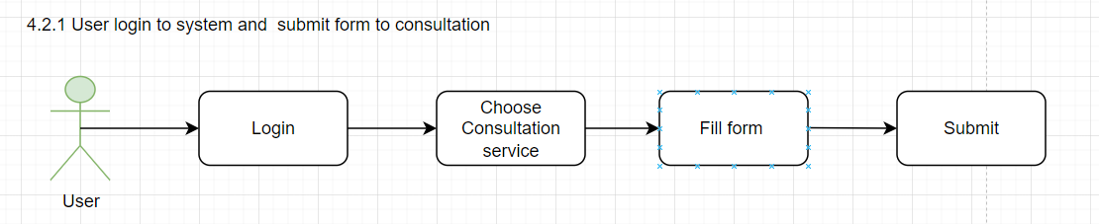

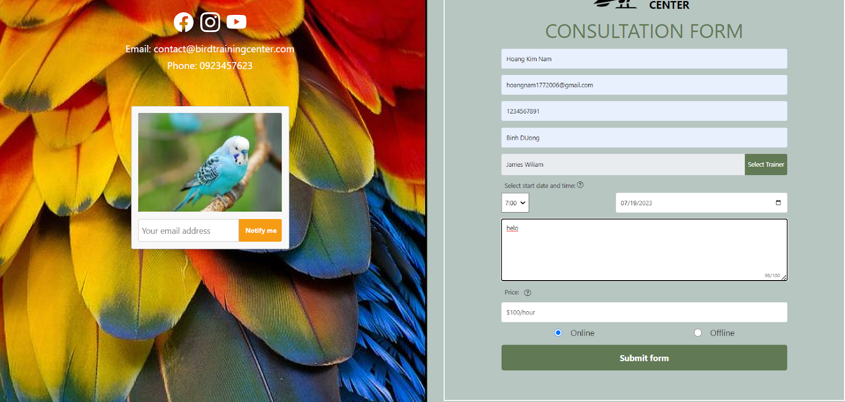

### Staff

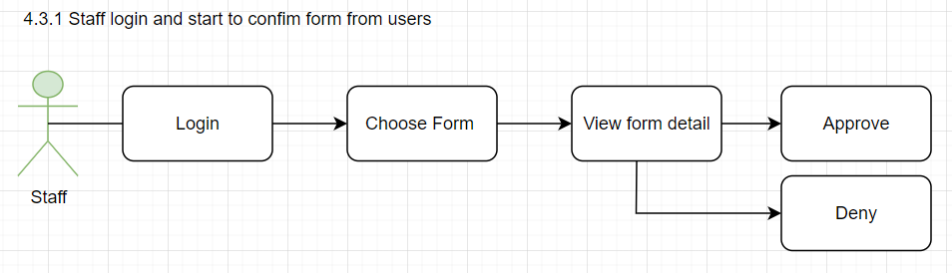

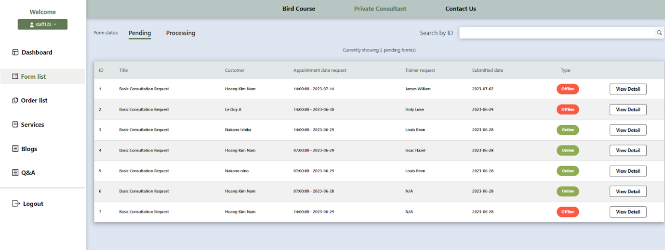

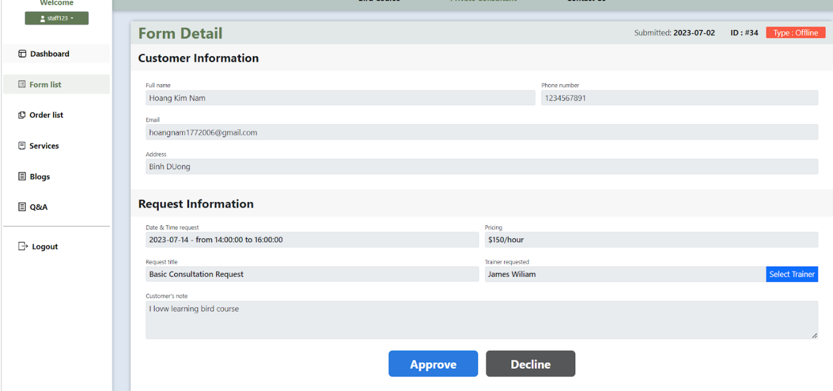

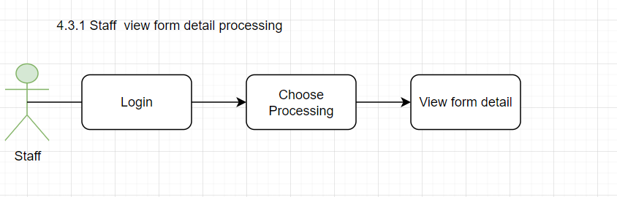

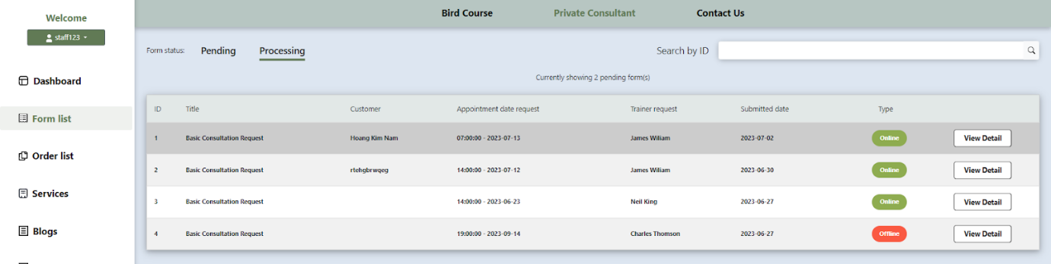

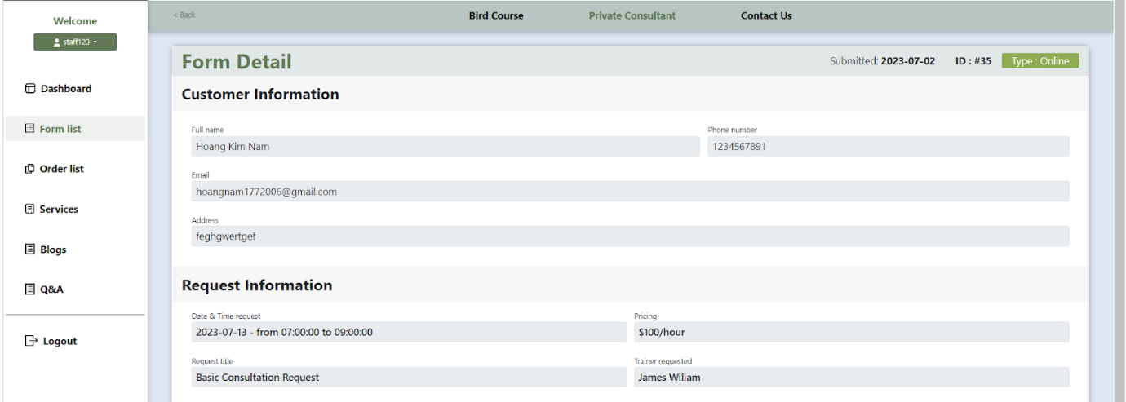

### Trainer

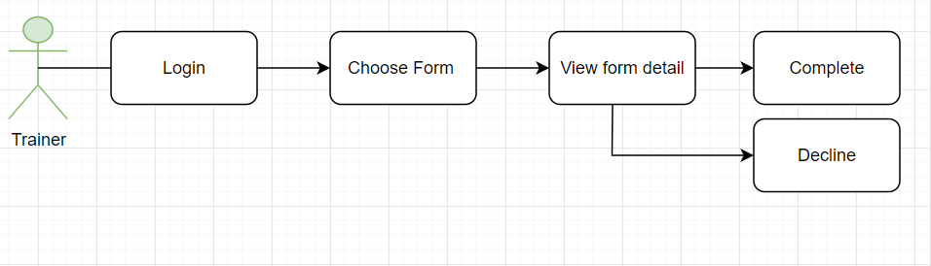

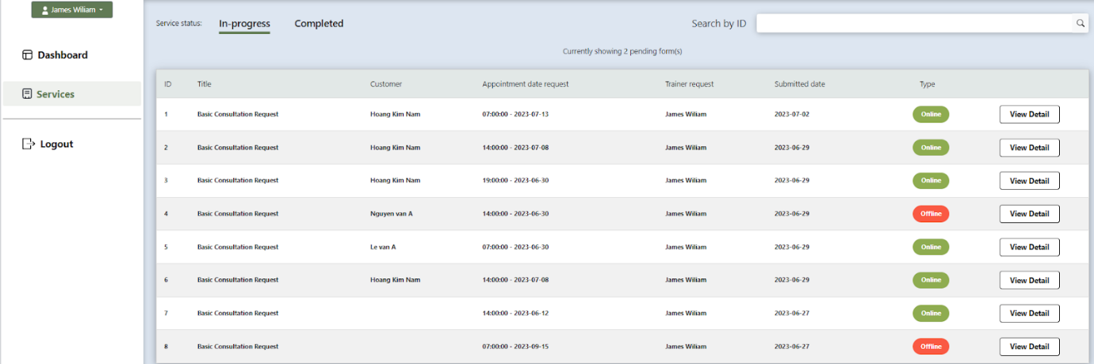

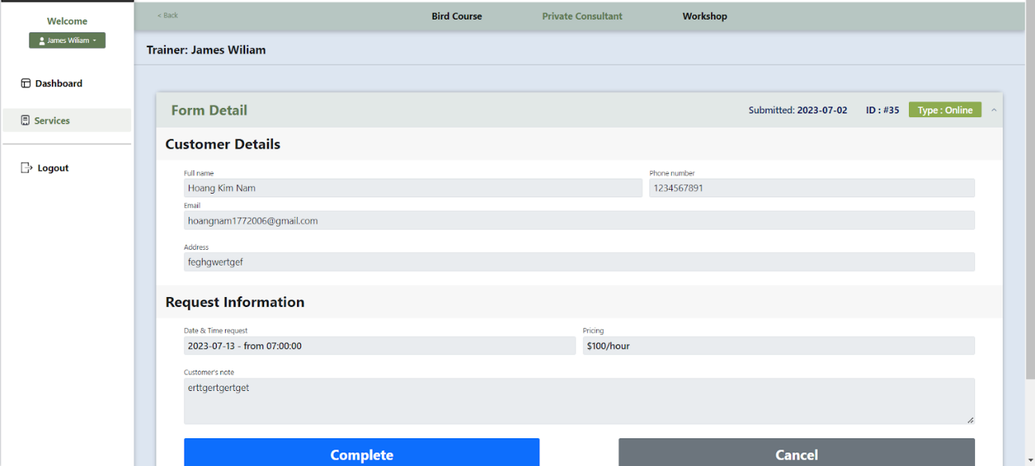

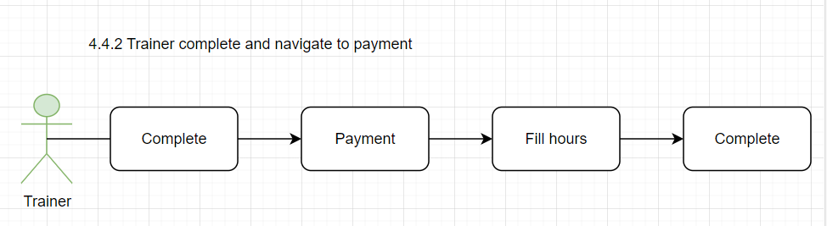

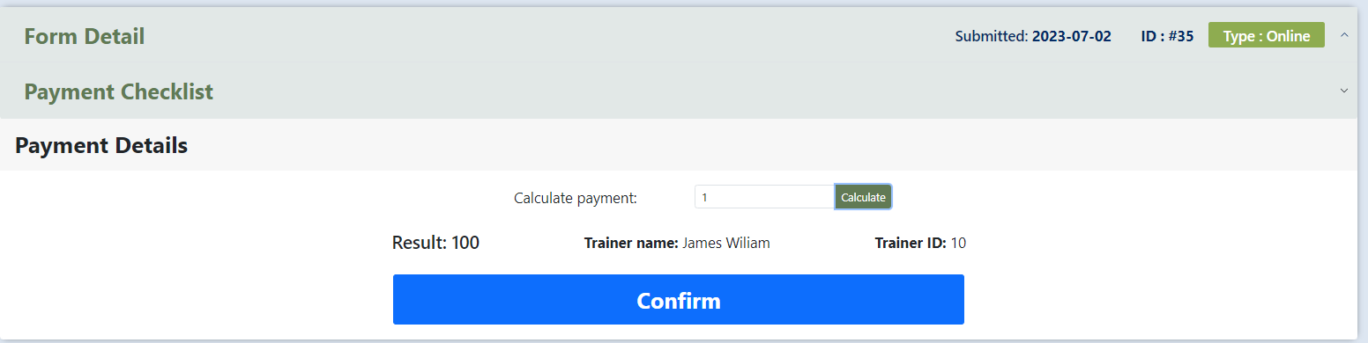

### Staff

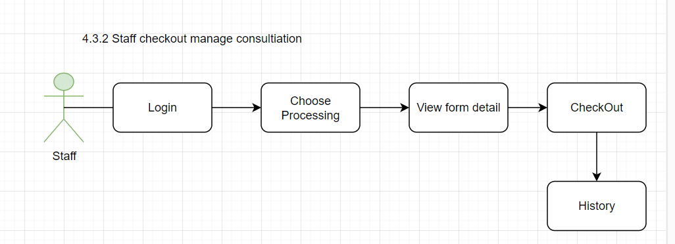

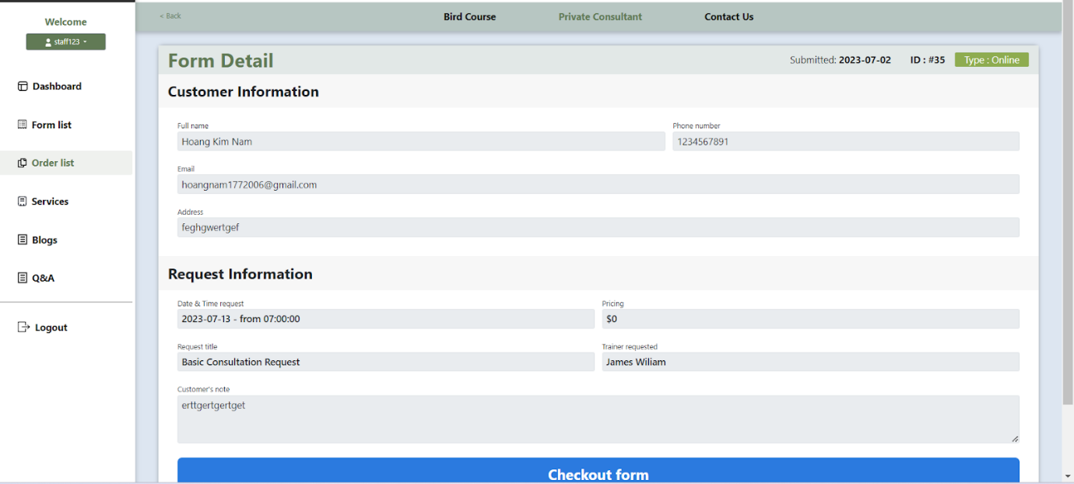

## 3. Blog

### Staff

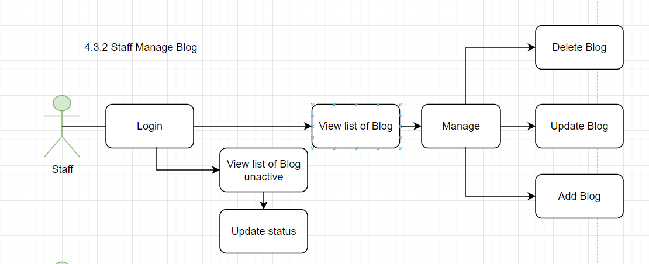

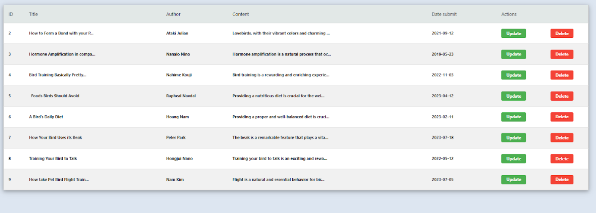

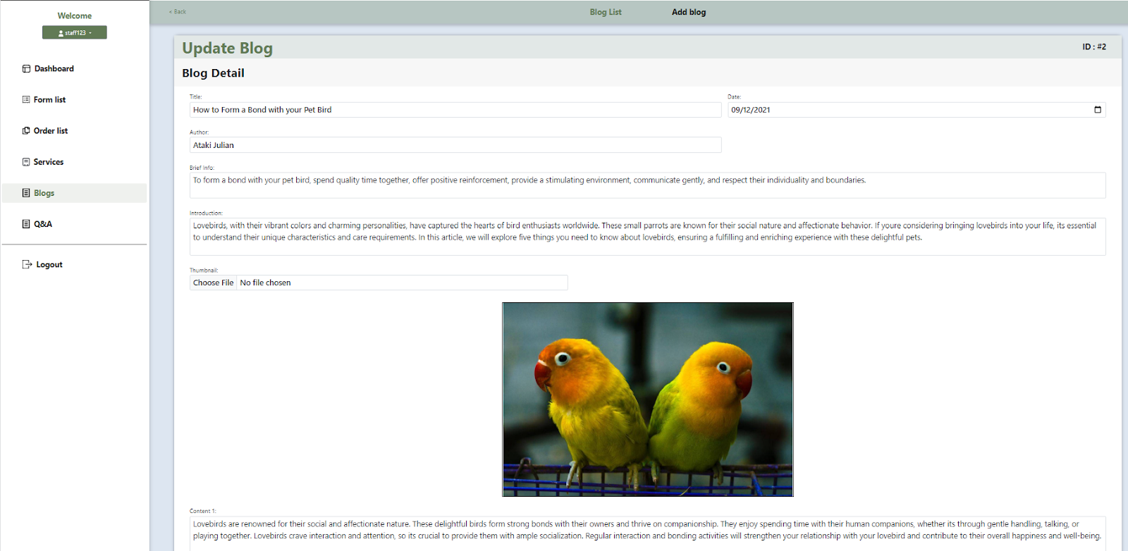

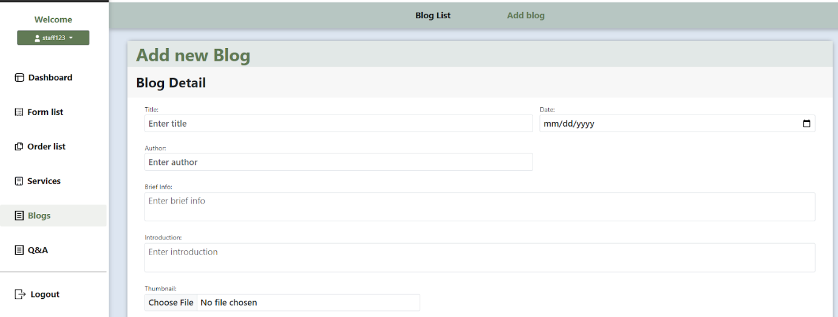

…

## 4. Workshop

### 4.1. User

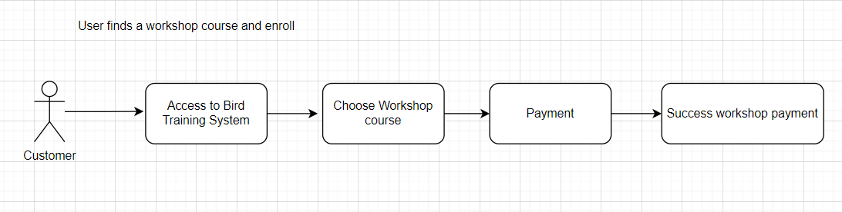

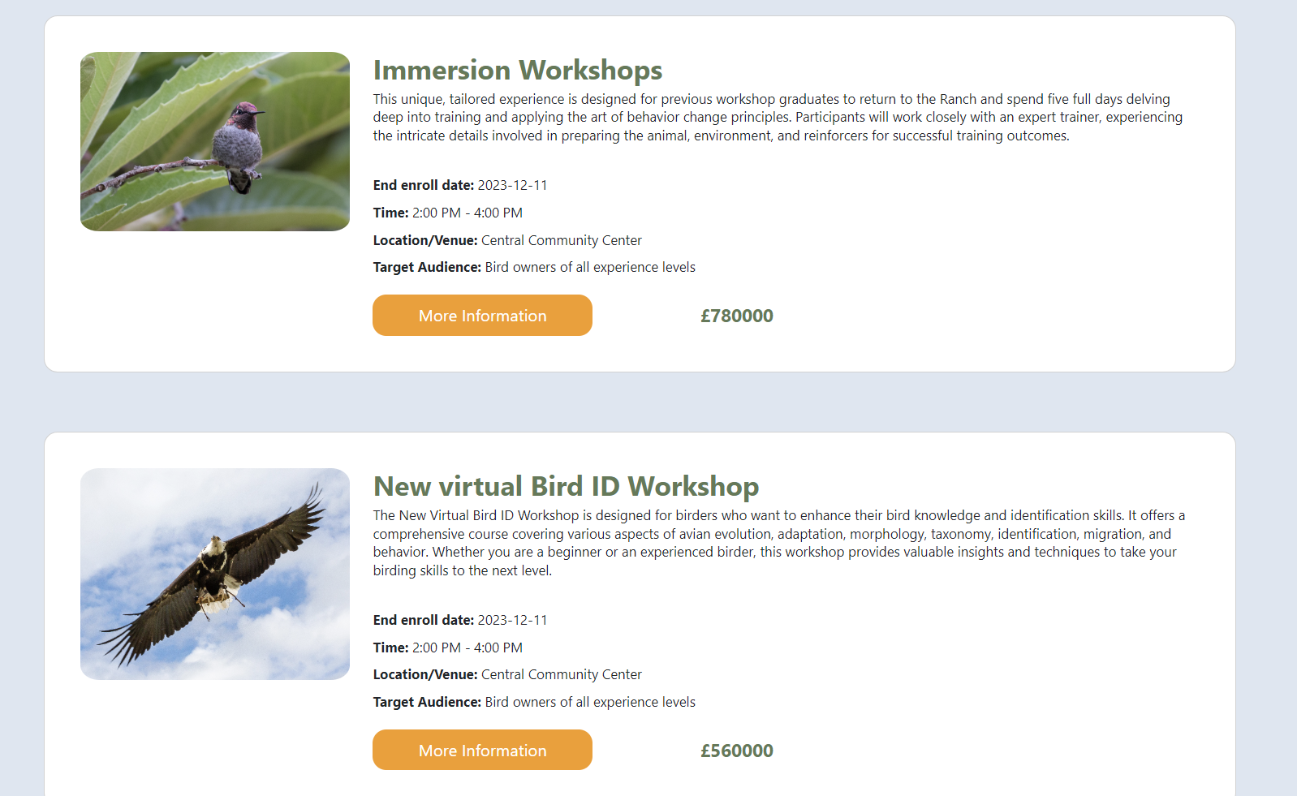



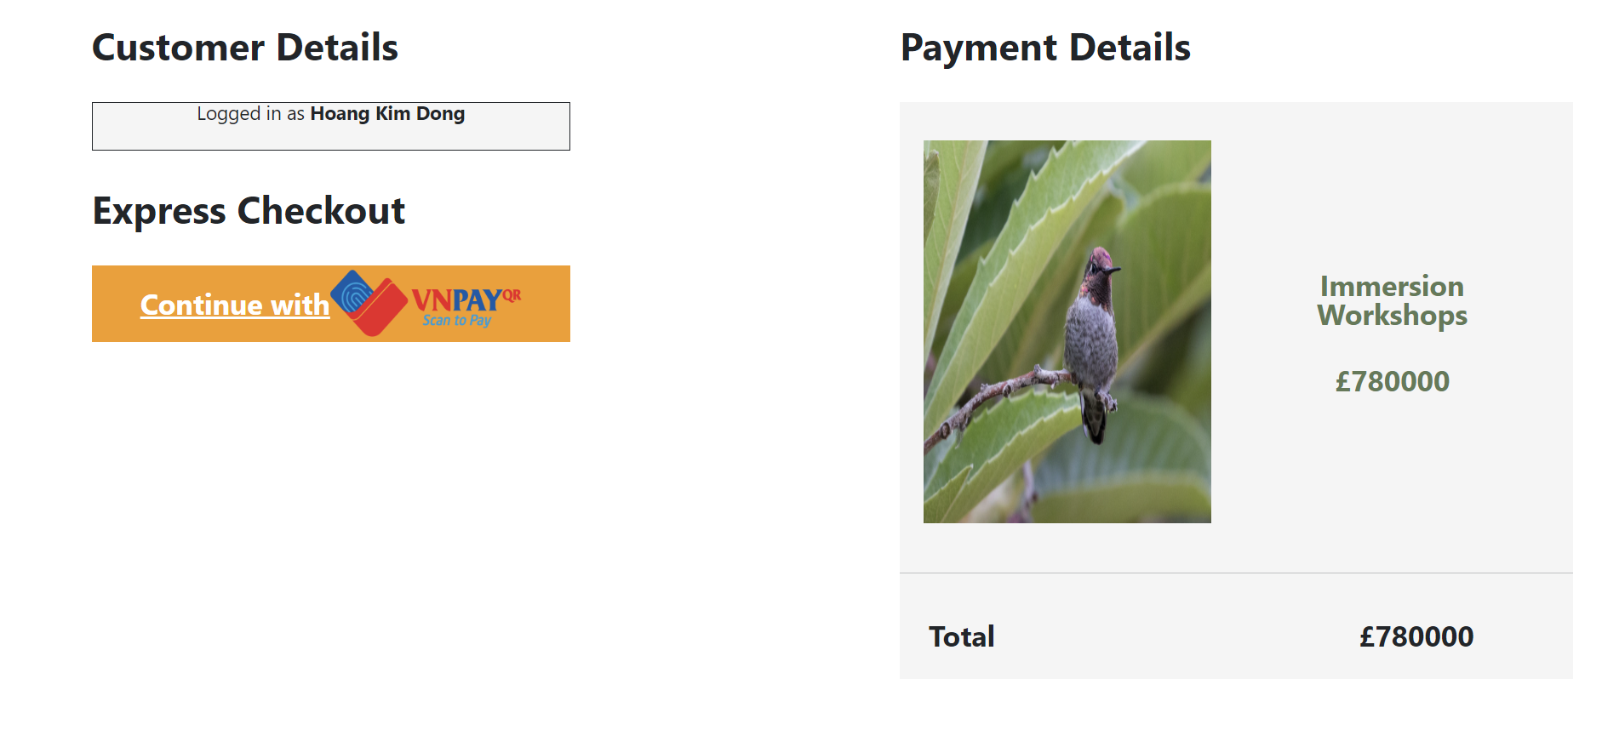

### 4.2. User_Workshop

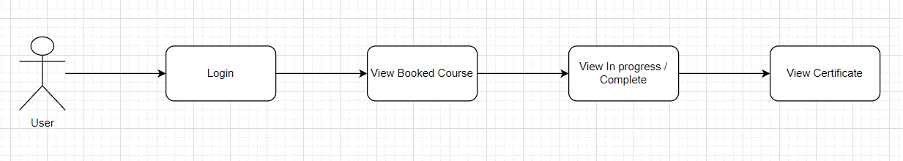

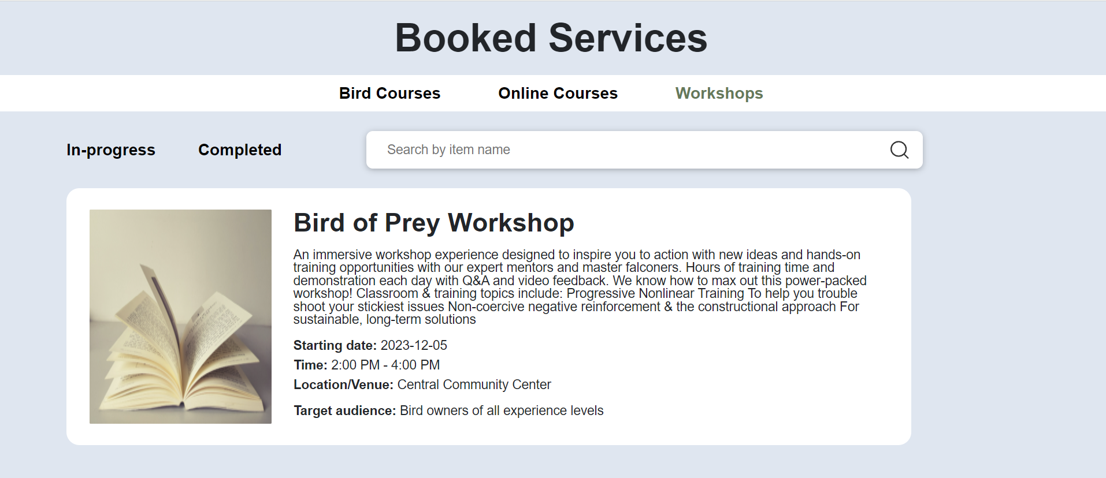

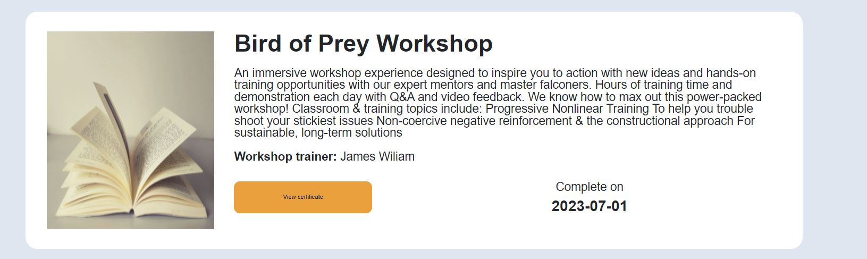



### 4.3. Staff

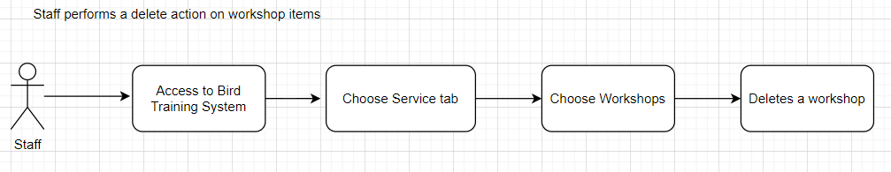

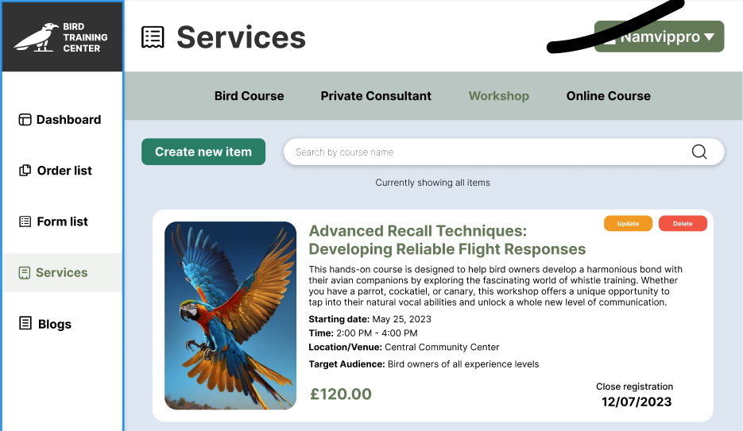

### 4.4. Staff

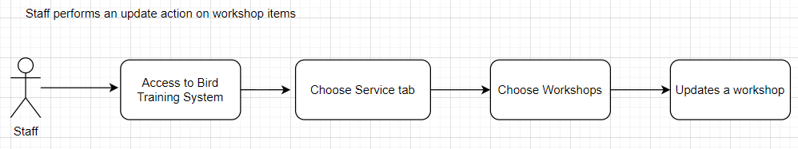

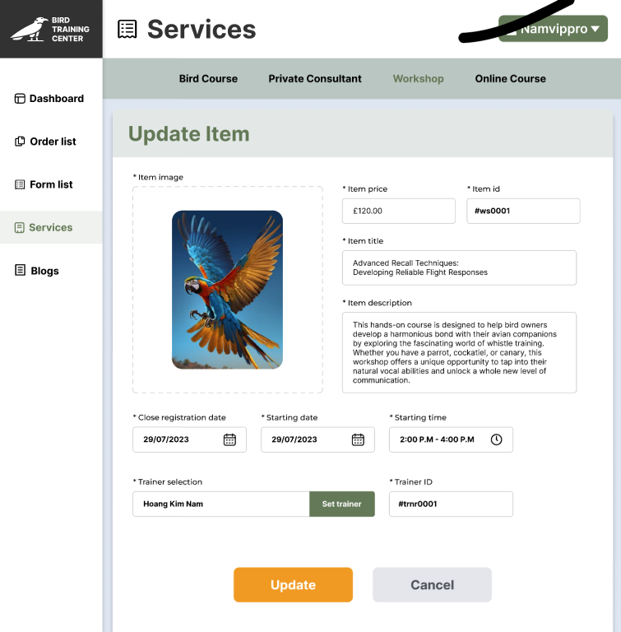

### 4.5. Staff

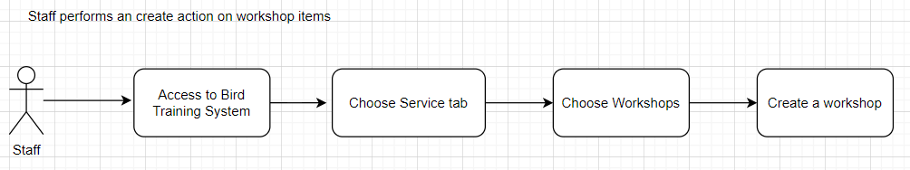

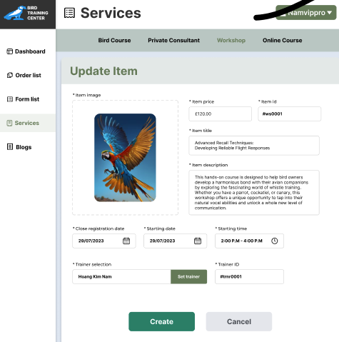

### 4.6. User_Edit Profile

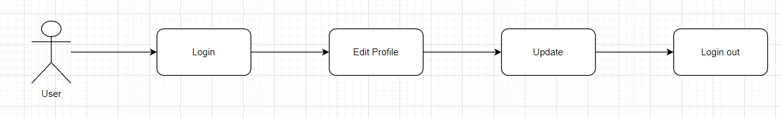

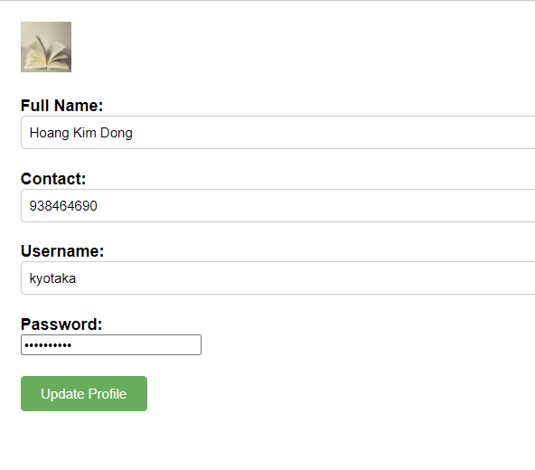

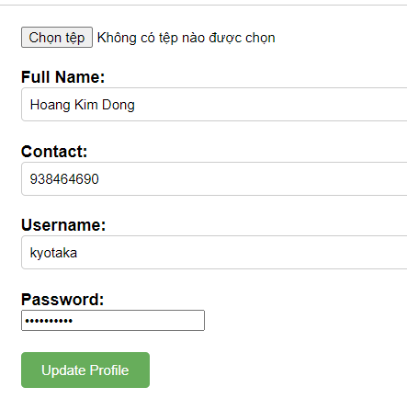

### 4.7. Staff_Update workshop

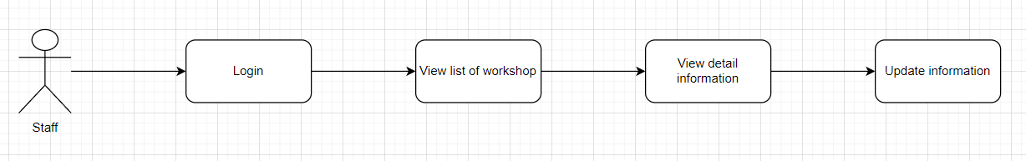  
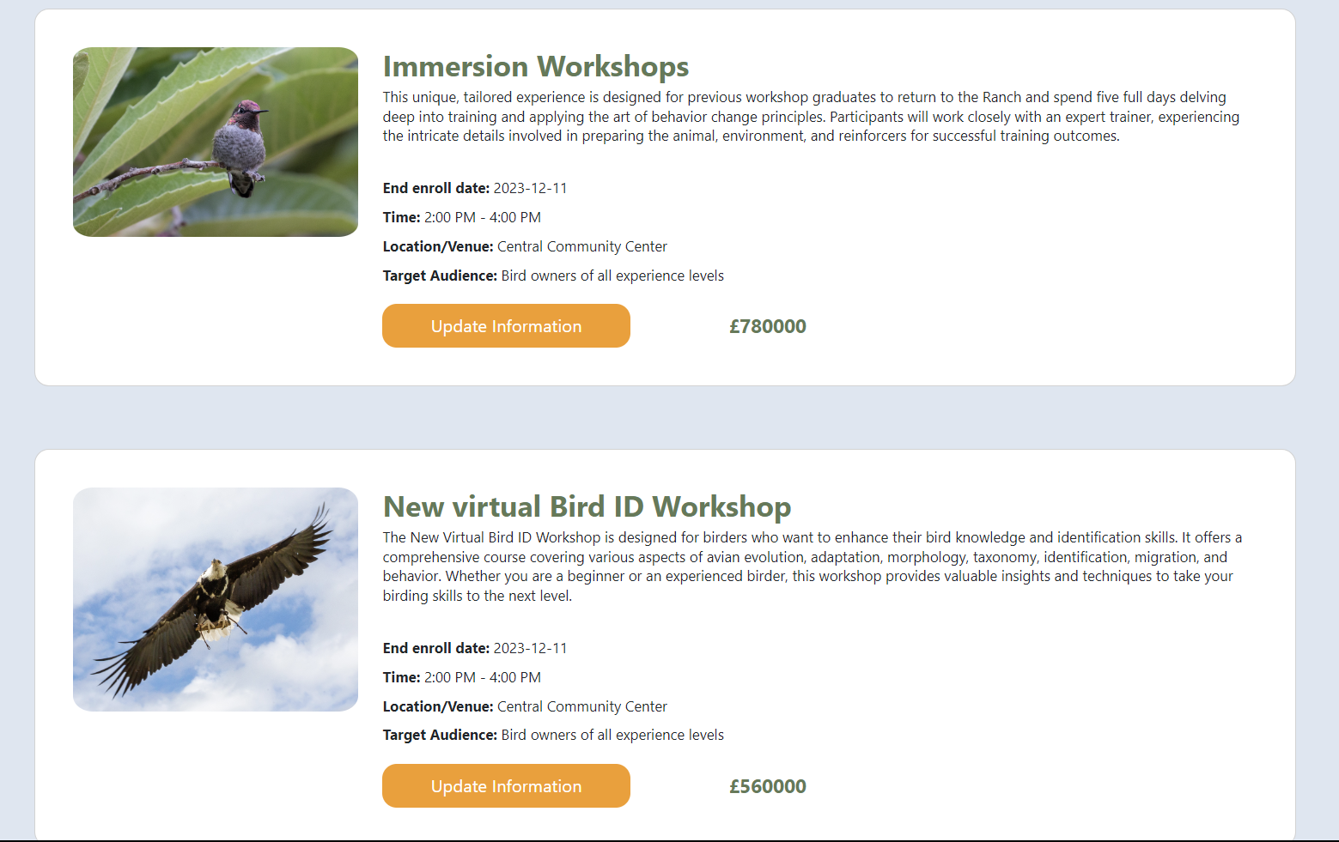

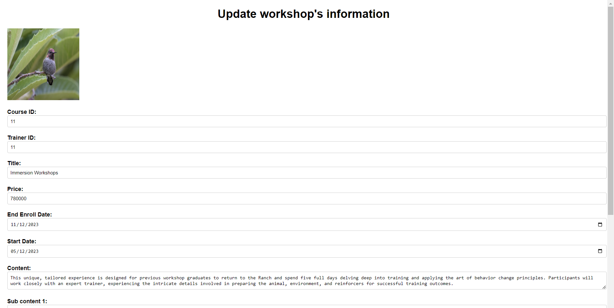

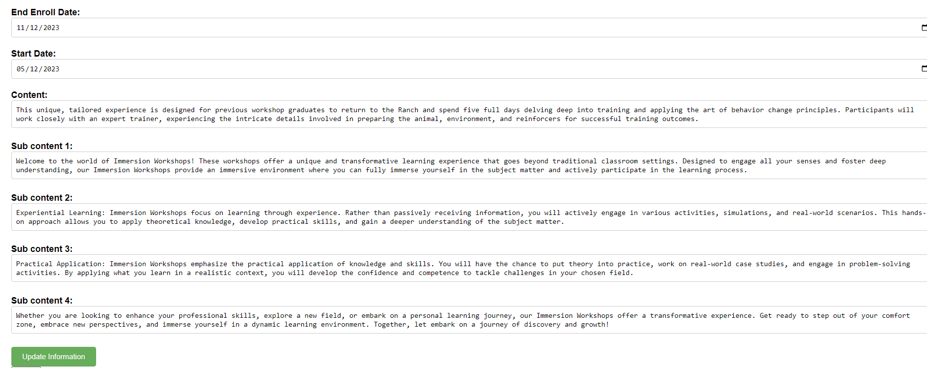

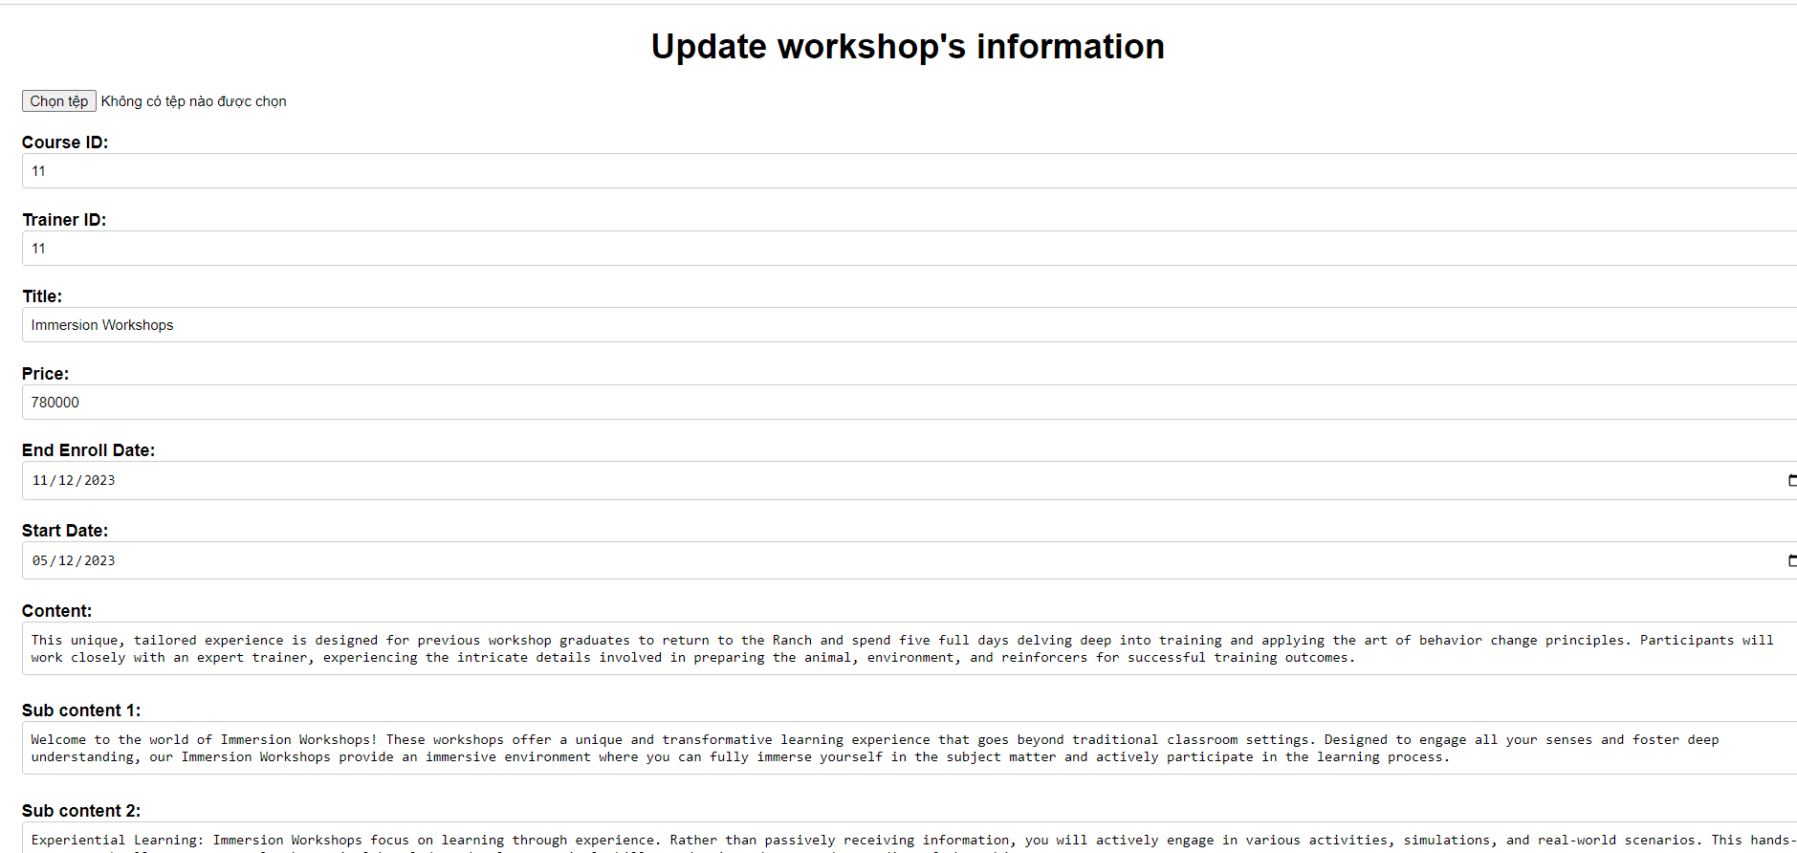

## 5. Bird course

### 5.1. User

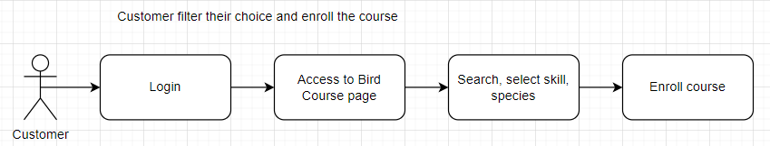

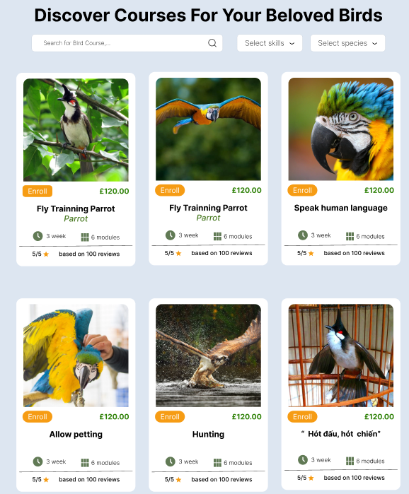

### 5.2. User

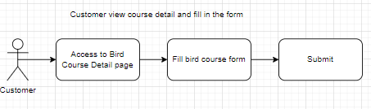

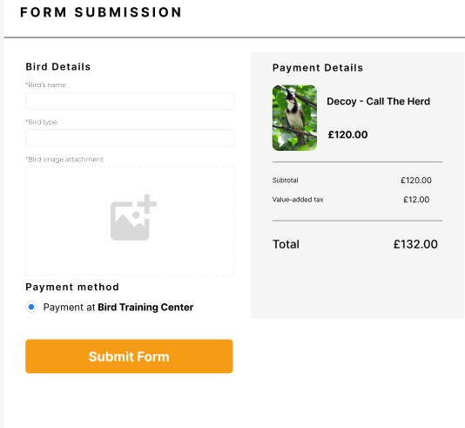

### 5.3. Staff

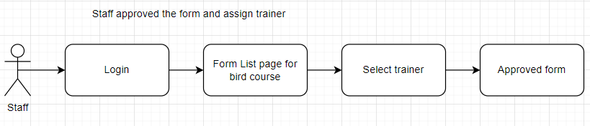

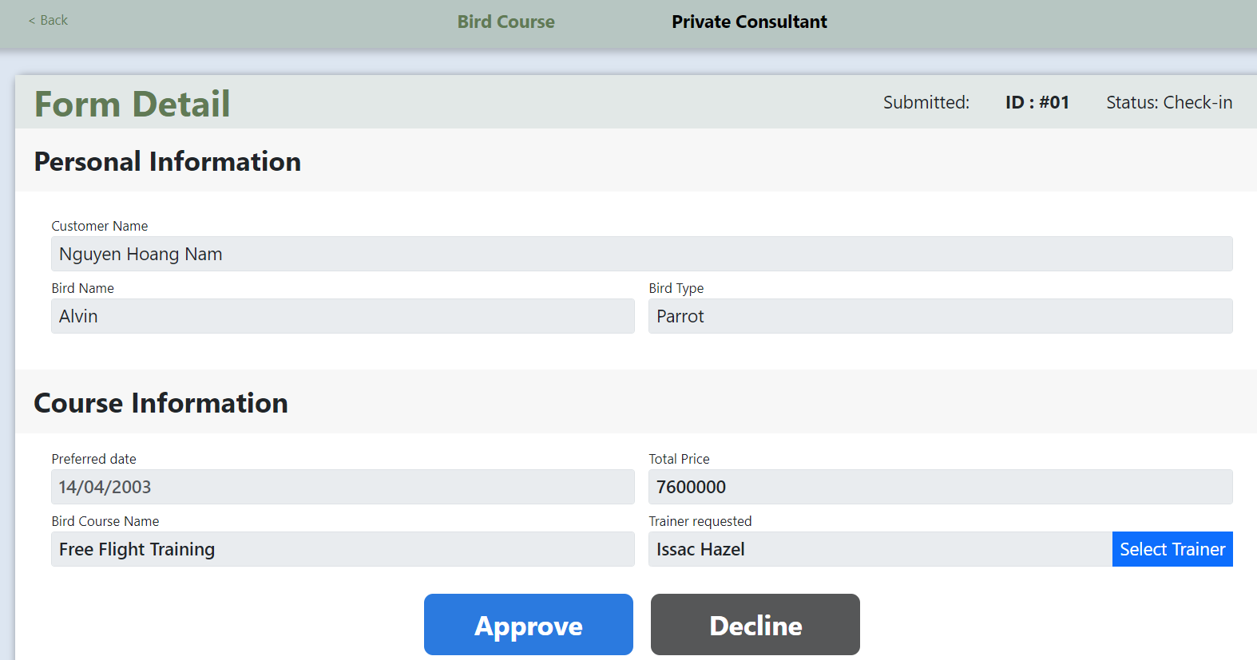

### 5.4. Staff

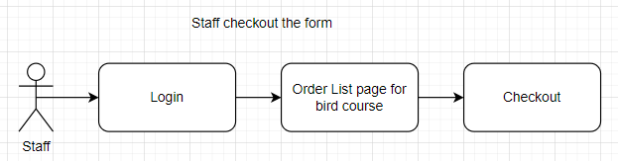

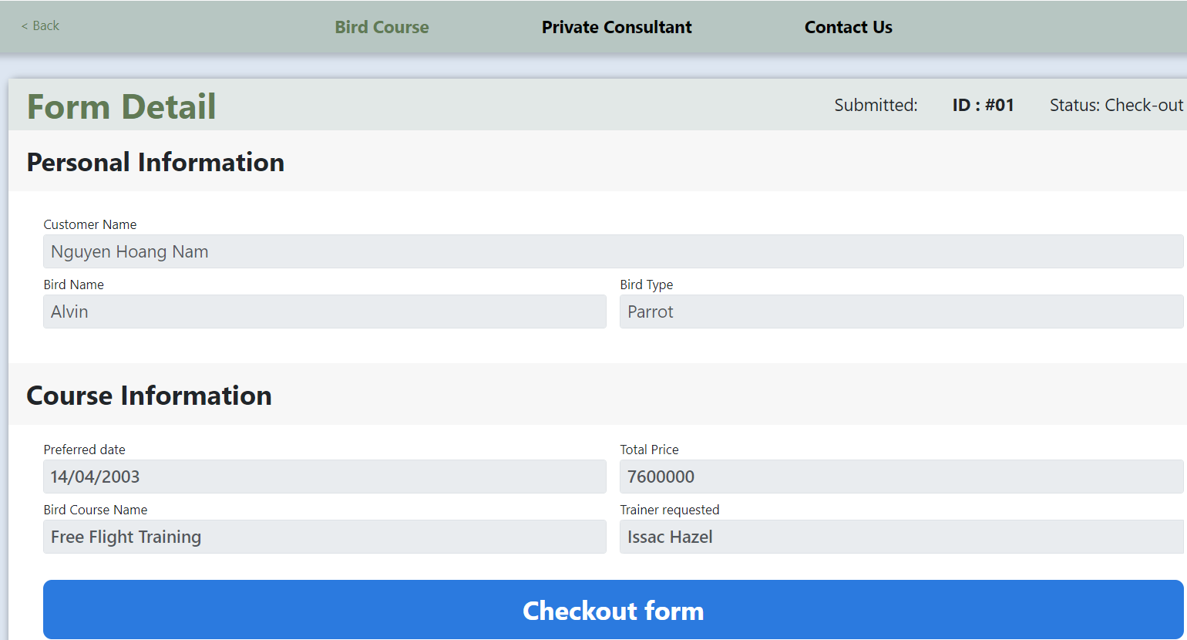

### 5.5. Trainer

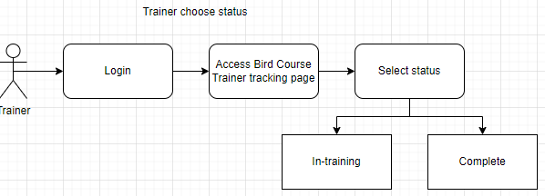

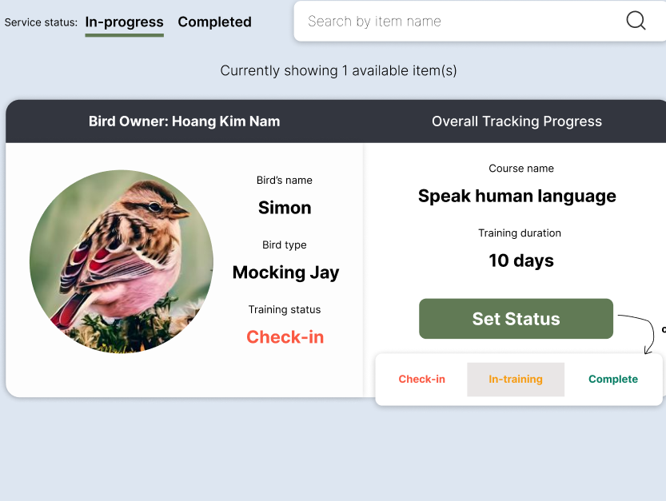

## 6. Online course

### 6.1. User

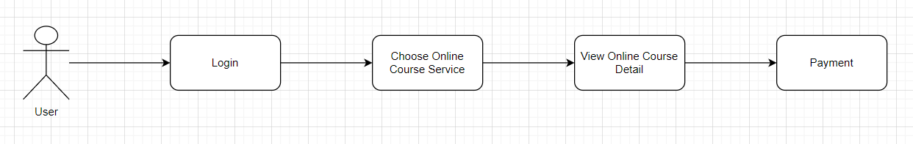

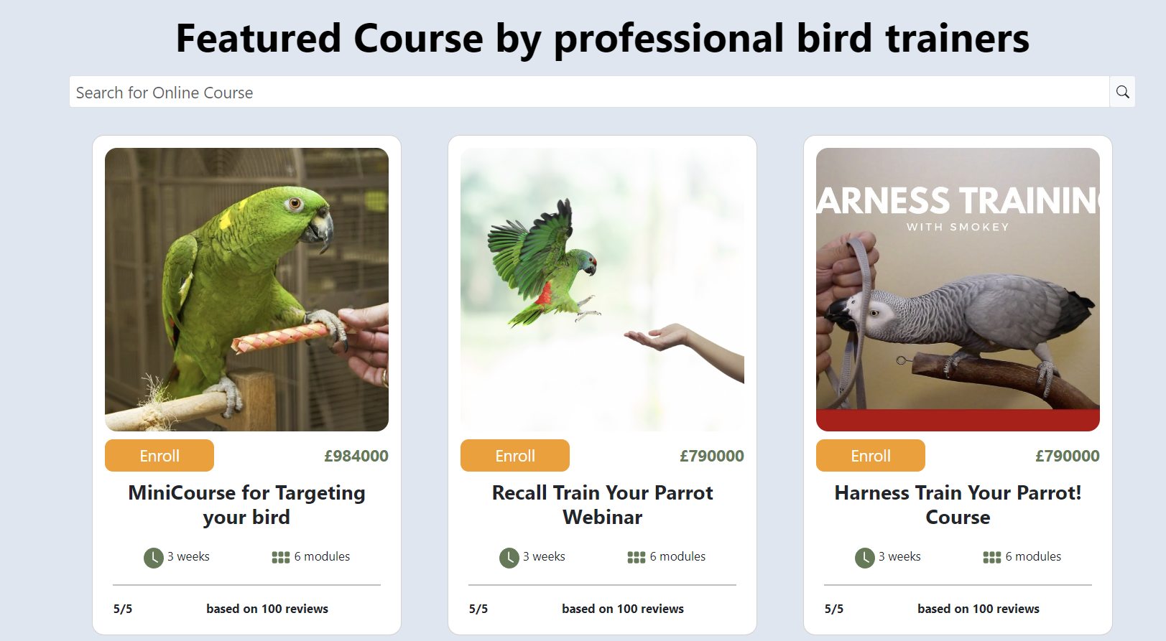

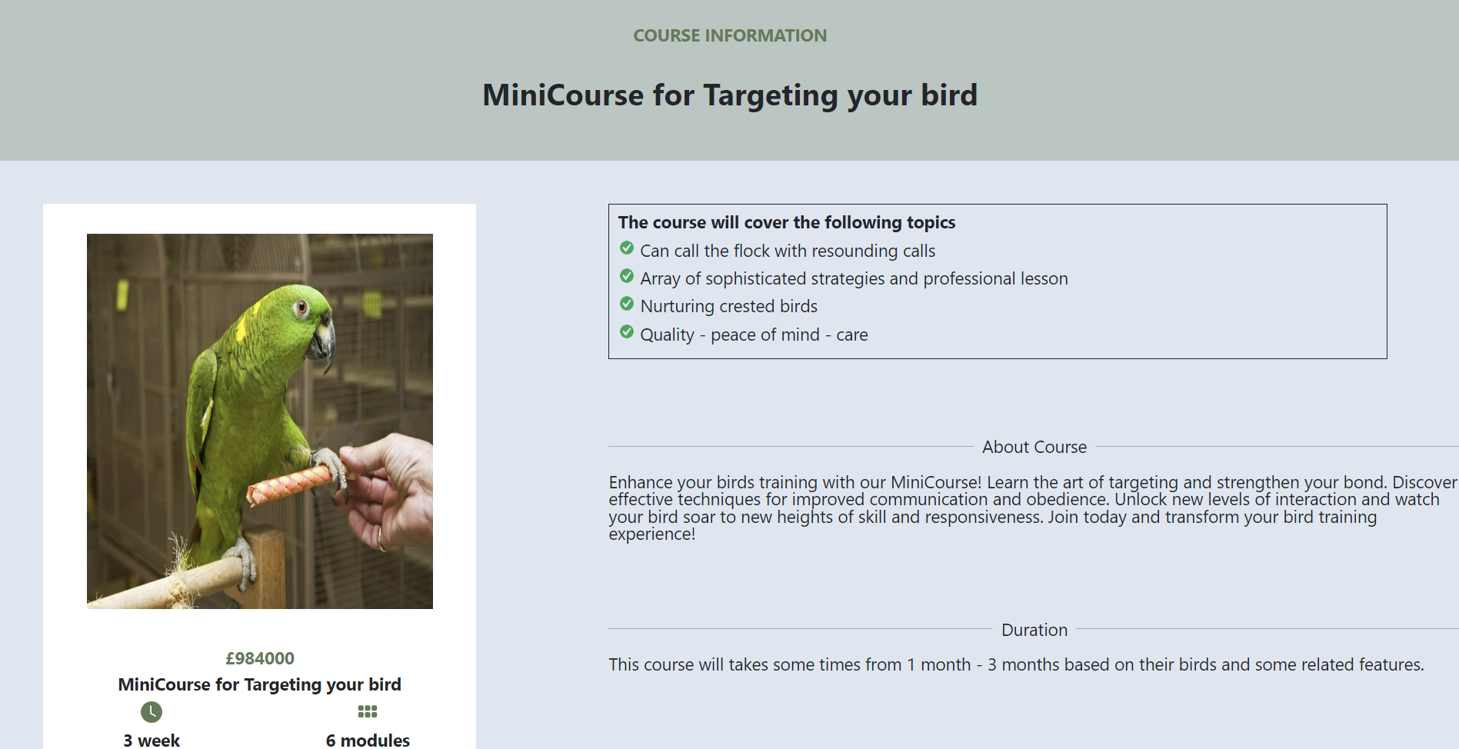

### 6.2. User

